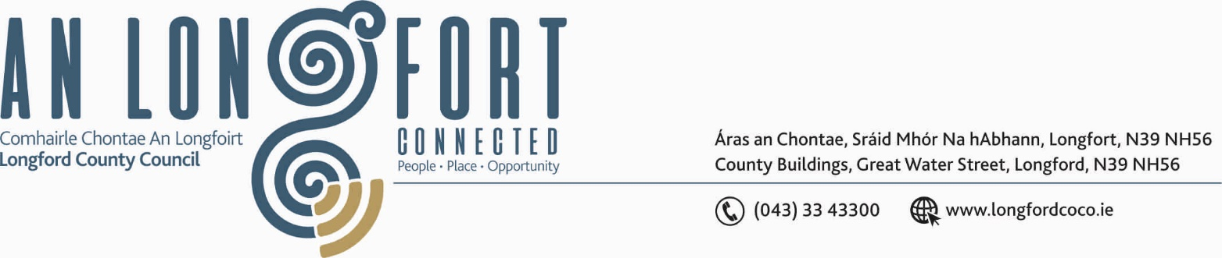

LONGFORD MUNICIPAL DISTRICT

Please note venue and time of meeting.

21st October 2020.

To: Each Member of Longford Municipal District.

Dear Member,

You are requested to attend Meeting of Longford Municipal District to be, held in
Longford Rugby Club, Demesne, Longford on Wednesday, 28th October 2020 at
4.30 p.m. to transact business, as set out on the Agenda hereunder.

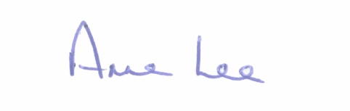
Yours sincerely,

_______________
Anne Lee,
Meetings Administrator.

AGENDA

Prayer before meeting.

- Confirmation of Minutes of meetings of Longford Municipal District held on
the 23rd September 2020 - copy enclosed

- Matters arising from Minutes.

- Declaration of Interest by Members.

- Management Report – to follow

- Consideration of 2021 General Municipal Allocation.
- Presentation by Senior Officer for Longford Town CCTV on the following –

- Longford Town CCTV – Alternative Measures Report
Consideration for adoption of report and included recommendations on the alternative measures implemented for Longford Town CCTV System
- Longford Town CCTV – Report on Public Consultation for Existing and Additional Cameras
Consideration for adoption of report and included recommendations on the public consultation held in relation to existing and additional camera locations for Longford Town CCTV System.
- Consideration for adoption of Data Privacy Impact Assessment Reports for existing and additional camera locations for Longford Town CCTV System.
- Consideration of letter of approval by LMD for the new CCTV locations as per the above reports.

- Consideration of letter of approval by LMD for upgrade of existing CCTV locations as per the above reports.

- Consideration of Free Parking arrangements during Christmas period.

- Update on Ballymacormack Cemetery Collabrium Wall.

- Notices of Motions, submitted by Councillors, as listed hereunder –

Councillor Uruemu Adejinmi.

“I call on Longford Chief Executive to consult with the owners of the old Garda building
on Dublin Street to enquire about their plans for the building and report to the Council at
the next MD Meeting.”

Councillor Martin Monaghan.

“That Longford County Council take in charge the road between R198 at
Creenagh and the road that leads to Prucklish Cross.

“That Longford County Council implements a Low Cost Safety Scheme on the L1007
Ballagh Road, Newtownforbes end before the turn off for the Curragranny road.”

“That Longford County Council looks at traffic calming measures on Farnagh Hill with the advent of the new housing development coming on stream soon it would be an ideal time to put in place these measures to alleviate traffic problems.”

Councillor Gerry Hagan.

“I call on Longford Municipal Area to take in charge the road which serves three Local
Authority houses on the Rhyne Lane. The road is in a hazardous condition and is in
serious need of surfacing so the families living there, can walk, cycle and drive safely to
their homes.”

Councillor John Browne.

“ I call on Longford County Council to put a Low Cost Safety Scheme in place at
Tully, Newtownforbes, where a number of road accidents have taken place.”



